Multiple Sequence Alignment of HBB (Haemoglobin Subunit Beta) Across Primates and Mouse: Evolutionary Conservation Analysis
Introduction
Multiple Sequence Alignment (MSA) is a technique in which more than two sequences can be compared to find the similarity or any difference that can be brought because of the evolutionary differences, functional or structural relationships. Unlike in BLAST, where we used to compare one sequence against the entire database. In MSA, multiple sequences can be compared in the same go.
In this task, five HBB protein sequences from five different organisms were used: human, gorilla, chimpanzee, and orangutan, representing a close relationship as they are all primates, and mouse, representing a distant species to show variation. This helps show how conserved the sequence is among primates and how distant it is from rodents. This is useful for HBB, as a single mutation at one position (Glu6Val) causes sickle cell anaemia. Therefore, understanding which positions stay conserved across species can reveal which parts of the protein are crucial to its function.
Method
In this task, we obtained the sequences of all five organisms - human, chimpanzee, gorilla, orangutan, and mouse from UniProt.
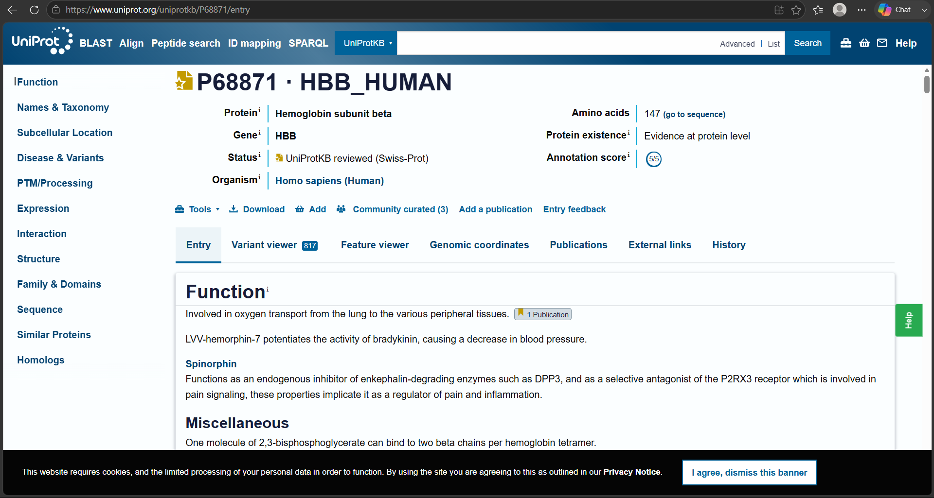
Figure 1: UniProt entry for HBB_HUMAN (accession P68871)
While collecting these sequences, we ensured that each corresponded specifically to the HBB (haemoglobin subunit beta) gene, since an initial search returned incorrect entries for orangutan and mouse (belonging to different, related genes), which were then corrected. After that, we pasted these five sequences into Clustal Omega, a tool that performs Multiple Sequence Alignment (MSA), using the EBI web server. After submitting the job, we obtained a result in which the aligned sequences were shown side by side, with a symbol row below them. These symbols (*, :, .) indicate different levels of conservation at each position.
Result
The Clustal Omega alignment gave a 147-position alignment for all five HBB sequences, shown in three blocks of around 60 positions each. The four primate sequences (human, gorilla, chimpanzee, and orangutan) were very similar to each other, with most positions being identical. The mouse sequence showed more differences compared to the primate sequences across all three blocks.
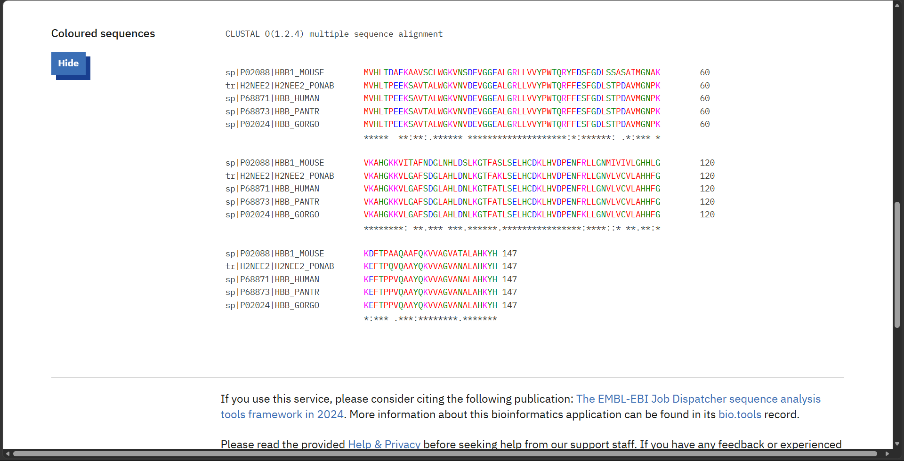
Figure 2: Multiple sequence alignment of HBB across 5 species (Clustal Omega)
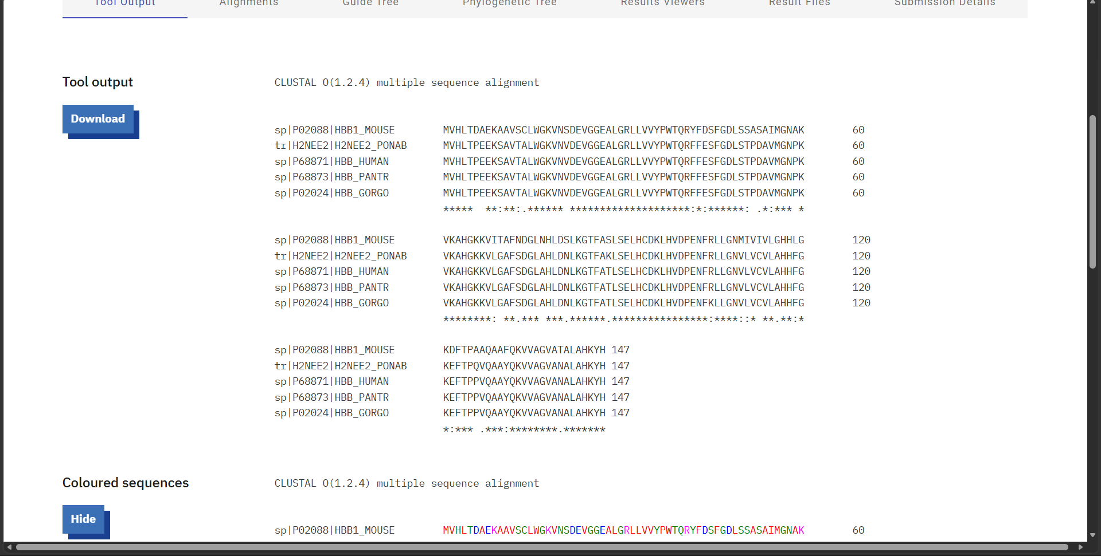
Figure 3: Clustal Omega alignment output (tool output view)
One important difference was seen at position 6/7, which is the site of the sickle cell mutation (Glu6Val). All four primate sequences had the same amino acid, Glutamic acid, at this position, while the mouse sequence had Alanine. This shows that the position is highly conserved among primates but differs between primates and rodents.
The full alignment output, including the conservation symbols below each block, is shown in Figure 1.
Discussion
The strong similarity between the primate sequences can be explained by their relatively recent common evolutionary history. Humans, gorillas, chimpanzees, and orangutans share a common ancestor, so there has been less time for major changes to occur in their HBB sequences. The mouse is more distantly related to primates and separated from their evolutionary lineage much earlier. Because of this, more differences have accumulated in its HBB sequence over time.
The difference at position 6/7 is especially important. All four primates have Glutamic acid at this position, showing that it is highly conserved among primates. The mouse, however, naturally has Alanine at the same position. This shows that the position can tolerate some changes, but the specific type of amino acid change is important. In humans, changing Glutamic acid to Valine causes sickle cell anaemia, while the Alanine found in mouse does not cause the same problem.
This result also supports the findings from Task 1, where the human and gorilla HBB sequences differed by only one amino acid. Both BLAST and MSA results show that HBB is a highly conserved protein, especially at important positions such as residue 6.
Since this region is both highly conserved and linked to an important disease-causing mutation, the next step is to study the three-dimensional structure of the protein. This will help us understand how the mutation affects the structure and function of haemoglobin. This will be discussed in Task 3.
Conclusion
In this task, Multiple Sequence Alignment was performed on five HBB protein sequences from human, gorilla, chimpanzee, orangutan, and mouse using Clustal Omega. The results showed that the four primate sequences were very similar to each other, while the mouse sequence had more differences because it is more distantly related to primates. An important difference was seen at position 6/7, where the Glu6Val mutation occurs. This position was conserved in all four primates but was different in the mouse sequence. This suggests that the effect of a mutation depends on the type of amino acid change and not just on the change itself. Overall, these results support the findings from Task 1 and show that HBB is a highly conserved protein. In the next task, the three-dimensional structure of HBB will be studied to understand how mutations at this important position can affect the protein's structure and function.

